Tutorial 4(CA)

1. Write the sequence of control steps required for bus structure in figure for the following instruction:
2. Add the (immediate) number NUM to register R1

**Step Action**

1. PCout, MARin, Read, Select4, Add, Zin
2. Zout, PCin, Yin, WMF C
3. MDRout, IRin
4. PCout, MARin, Read, Select4, Add, Zin
5. Zout, PCin, Yin
6. R1out, Yin, WMFC
7. MDRout, SelectY, Add, Zin
8. Zout, R1in, End

2. Generate Zin and END control signals for the processor using hardwired control unit

a) Zin = T1 + T6 • ADD + T4 • BR + …

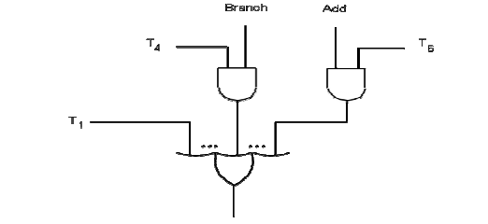

b) End = T7 • ADD + T5 • BR + (T5 • N + T4 • N) • BRN +…

